## Analysis Report

Hanan Ali

**About the Data**

The data is about tweets made in 2020 in Twitter social public account of “Amber Heard”.

It contains 621583 tweets explained by 7 features.

**After wrangling the data we have some estimations:**

1. No. of all users in the data is 196251 made 612583 tweet in 2020.:

* 28391 users fresh created in 2020 (14.45% from the whole users) made 132711 (21.67% from all tweets).
* 5439 users(4.098% from users_created_2020) tweeted in the same day they created their account.
* (16.22%) of users_created_2020 tweeted within 14 days of account creation.
* The rest of users created in many years from 2006 to 2020 made 479872 tweet

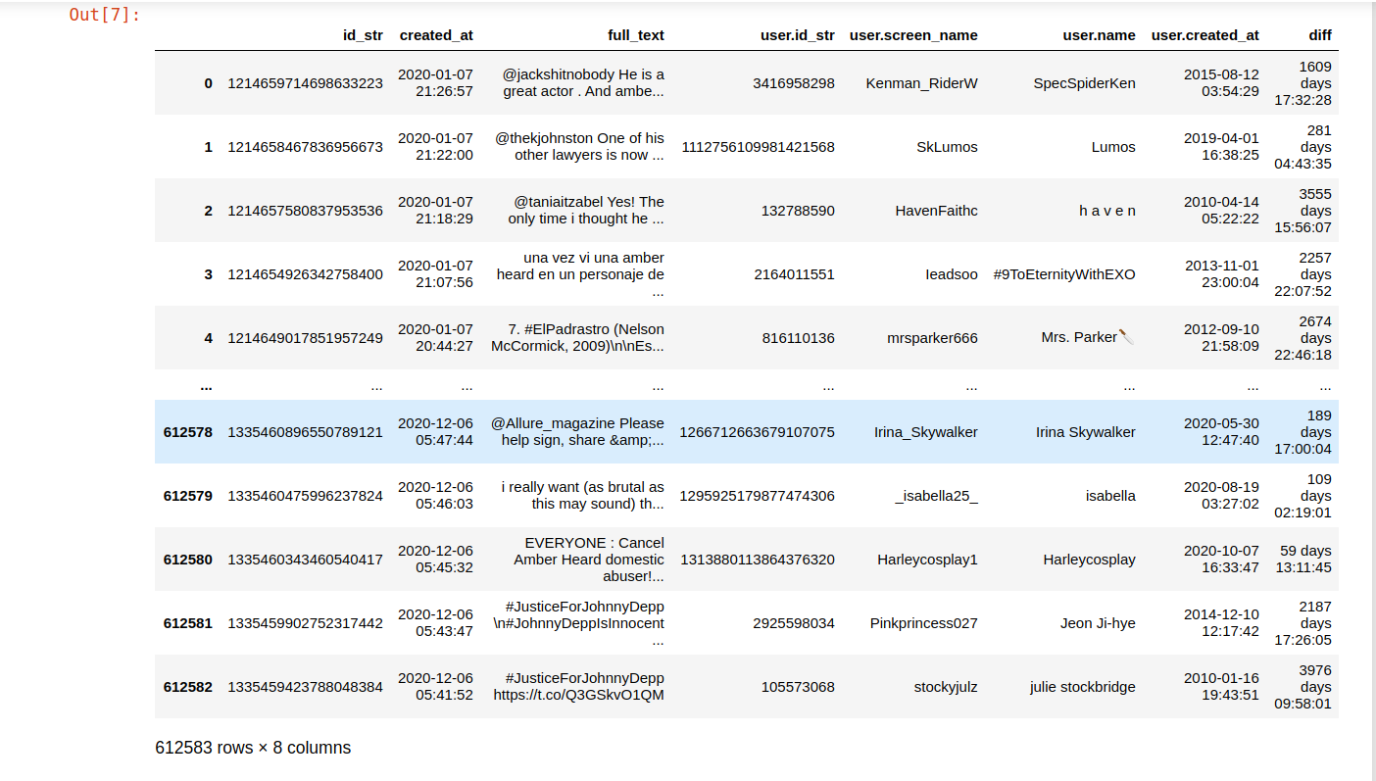

2. Here can explain more how the no. Of users created in 2020 in interesting.

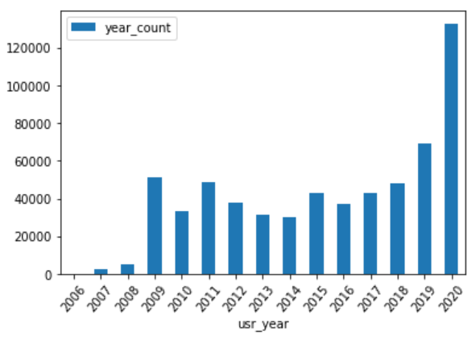

3. Many users created in certain months (mostly in Jul. ,Nov. Aug., may., oct., feb) in 2020 with interesting way.

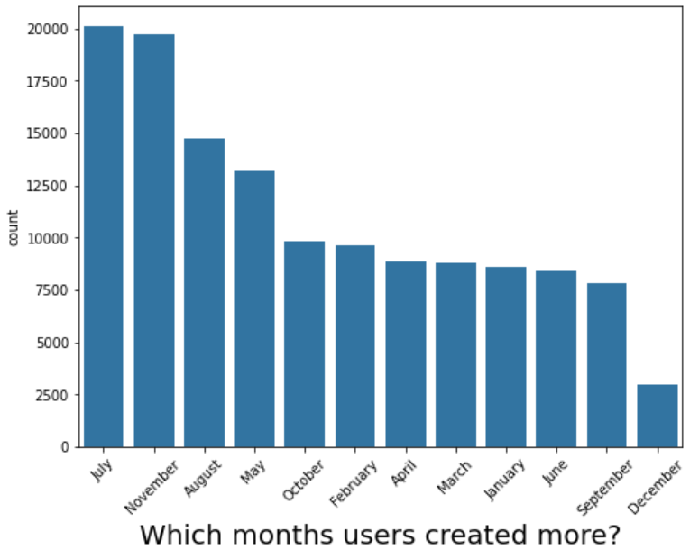

5. By checking the tweets, found interesting insight top months of tweets were ( Nov., Feb., July.,Dec., Aug) so we have matching here with users creation

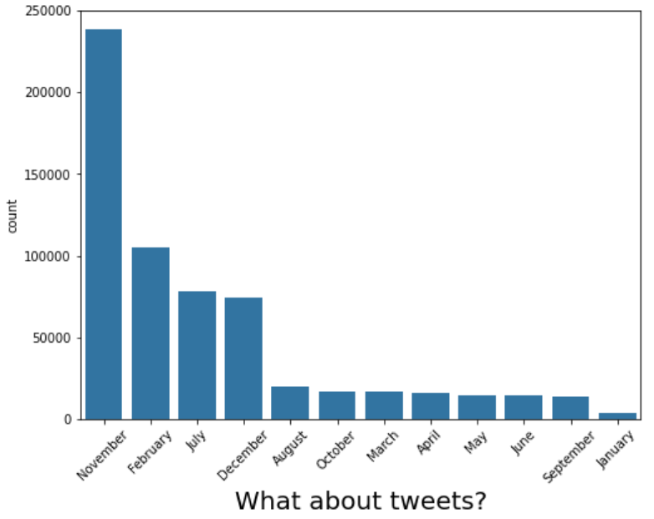

6.A very susbicous insight upcoming now, when making distribution for the data according to the time diffrence between creation of user and his tweet found that within users created in 2020 most of them created in the same days and others in few days.

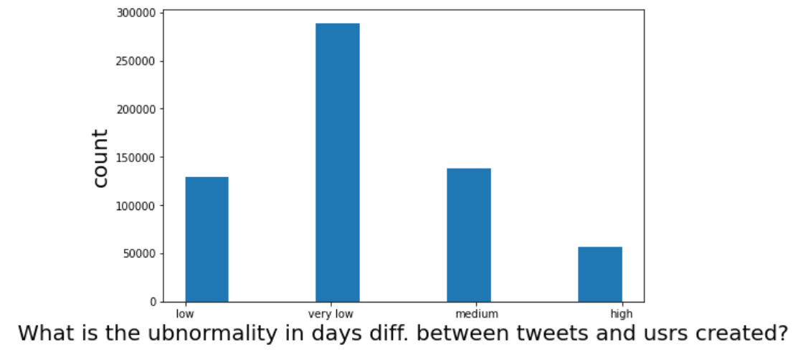

** This want to be mixed to see the relation between tweet_month and users created in these months to figure out the most bulku months and make the relation more obvious

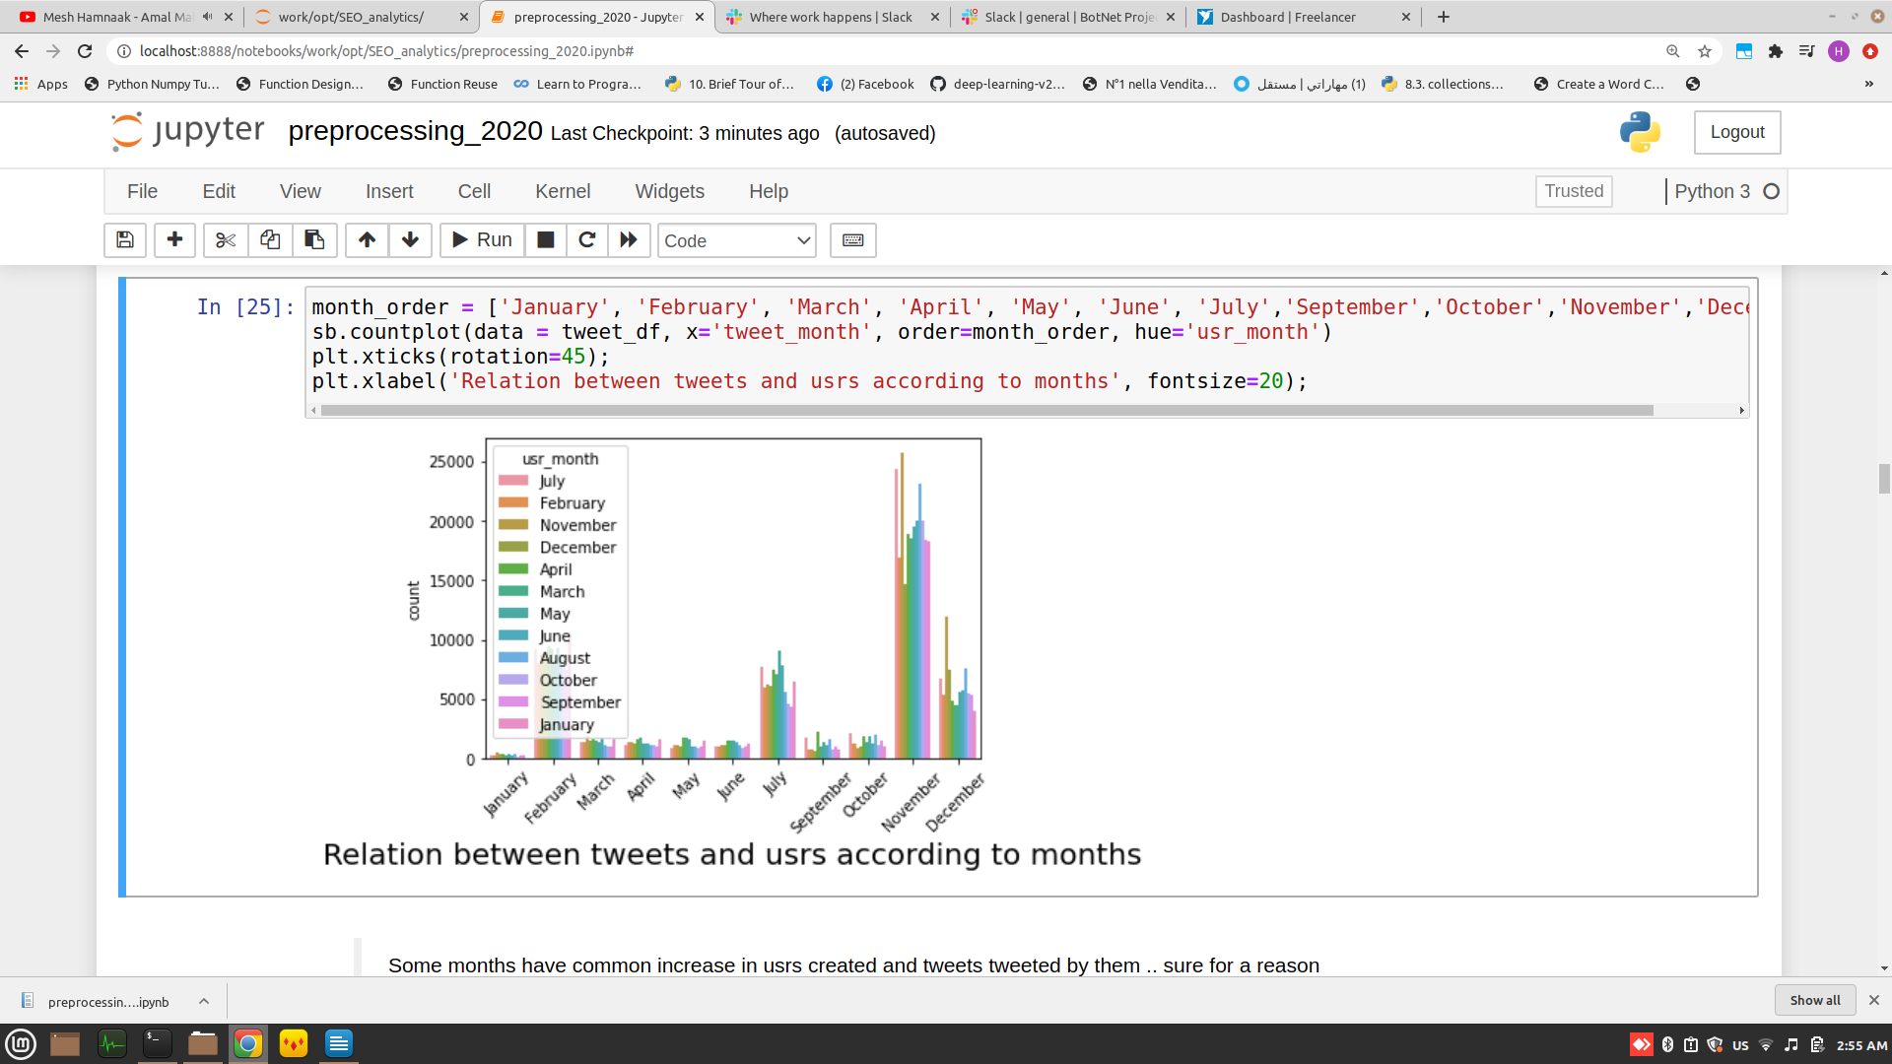We can see the relation between the bulky tweet months and crowded user creation months .. they share the same months that have already the most trendy dates.

There must be few events caused the activity for users in those specific months.

7. Also relating to the months of tweets in Jan., Feb. the days diff is less than one day more than other months and Mar., may., jul. the days diff is also in a very short period of time than rest of the months.

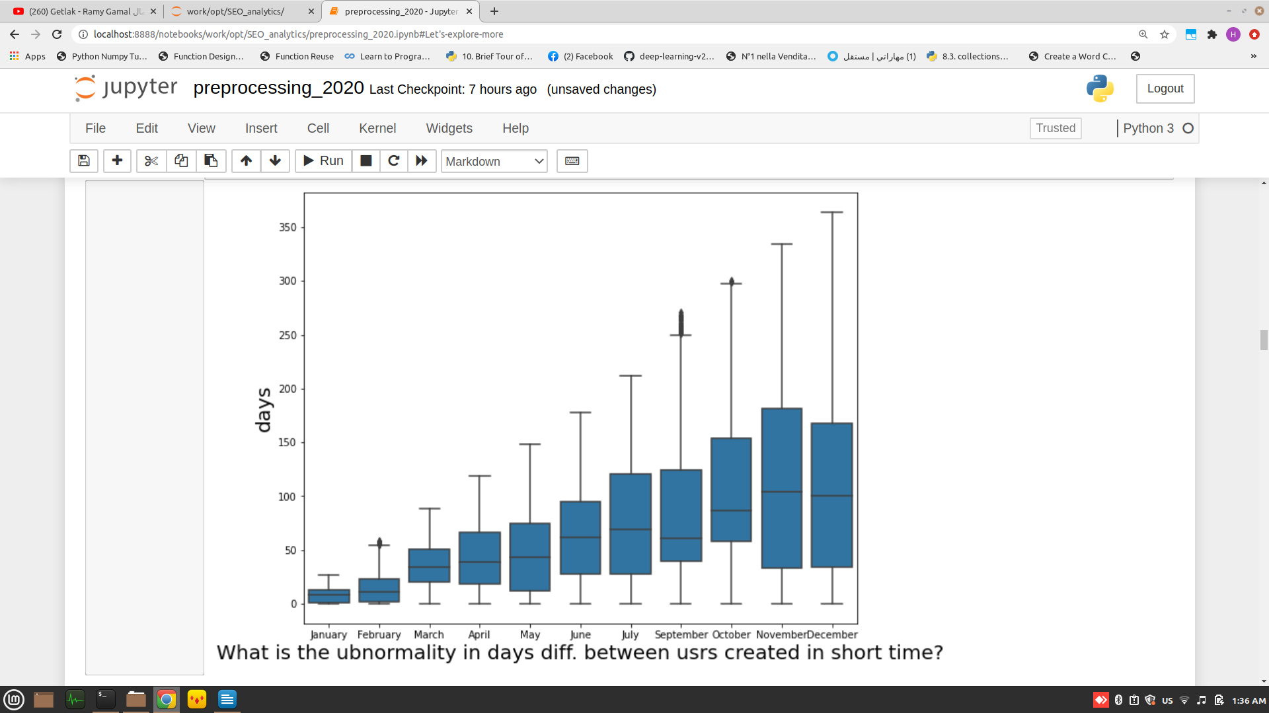

8. According to user month of creation .. users created in jan. and feb. are the most users tweeted in a short time and for jul. and nov. and dec. not alot of tweets but they are the most tweeted in almost 1 to 20 days of creation.

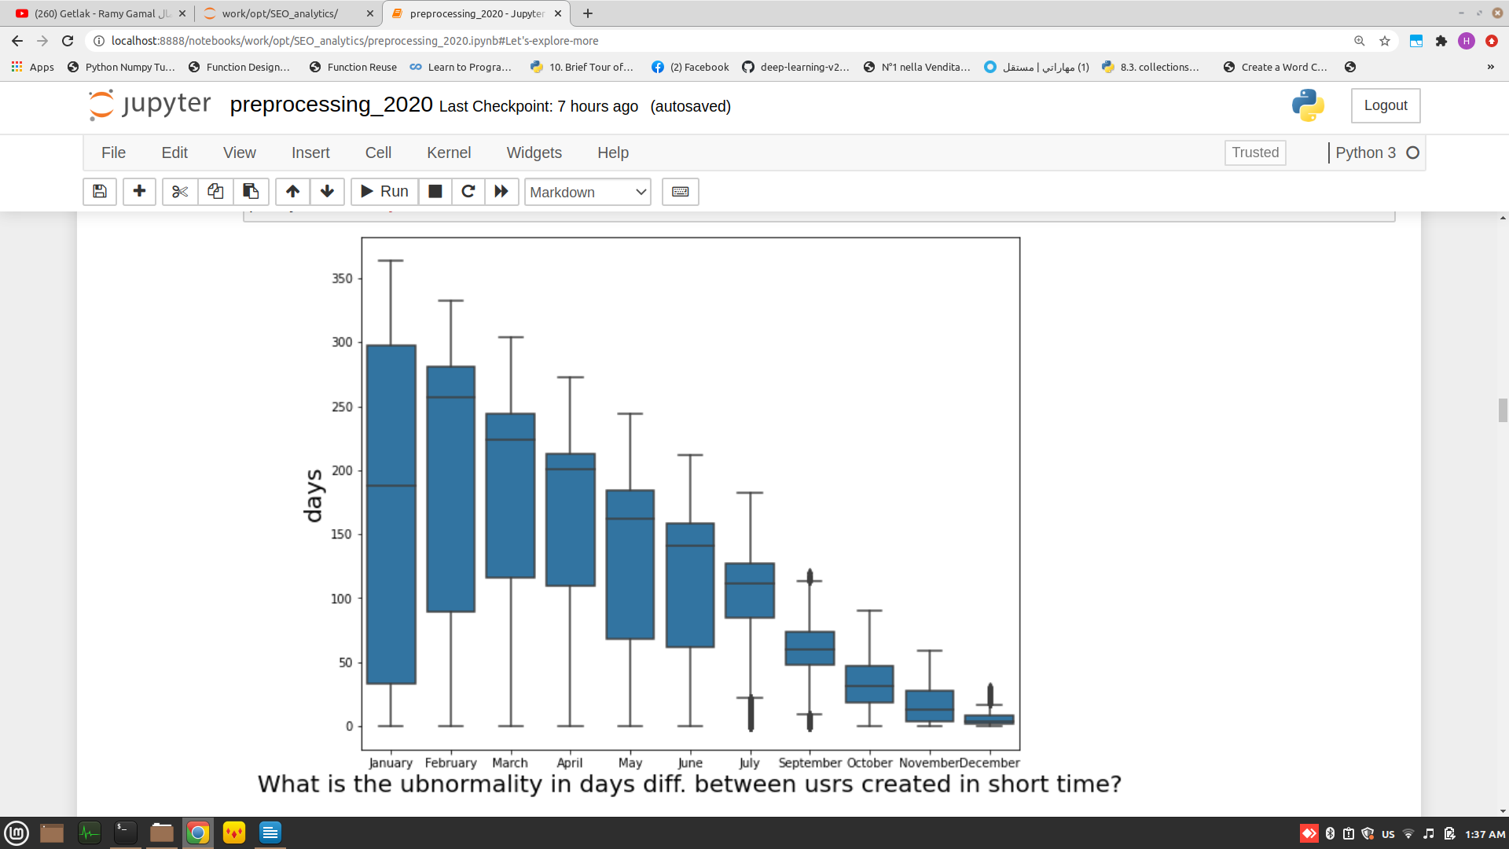

9. Also the users created in 2020 had periods of activities that means many of them were gitting active for a reason, According to Usrs created in jan have the most tweets but have croudy regions as it appears .. first regions after they created then decreased their activity, then increased again between 150 - 200 days of creation ..etc, the same for the rest of months.

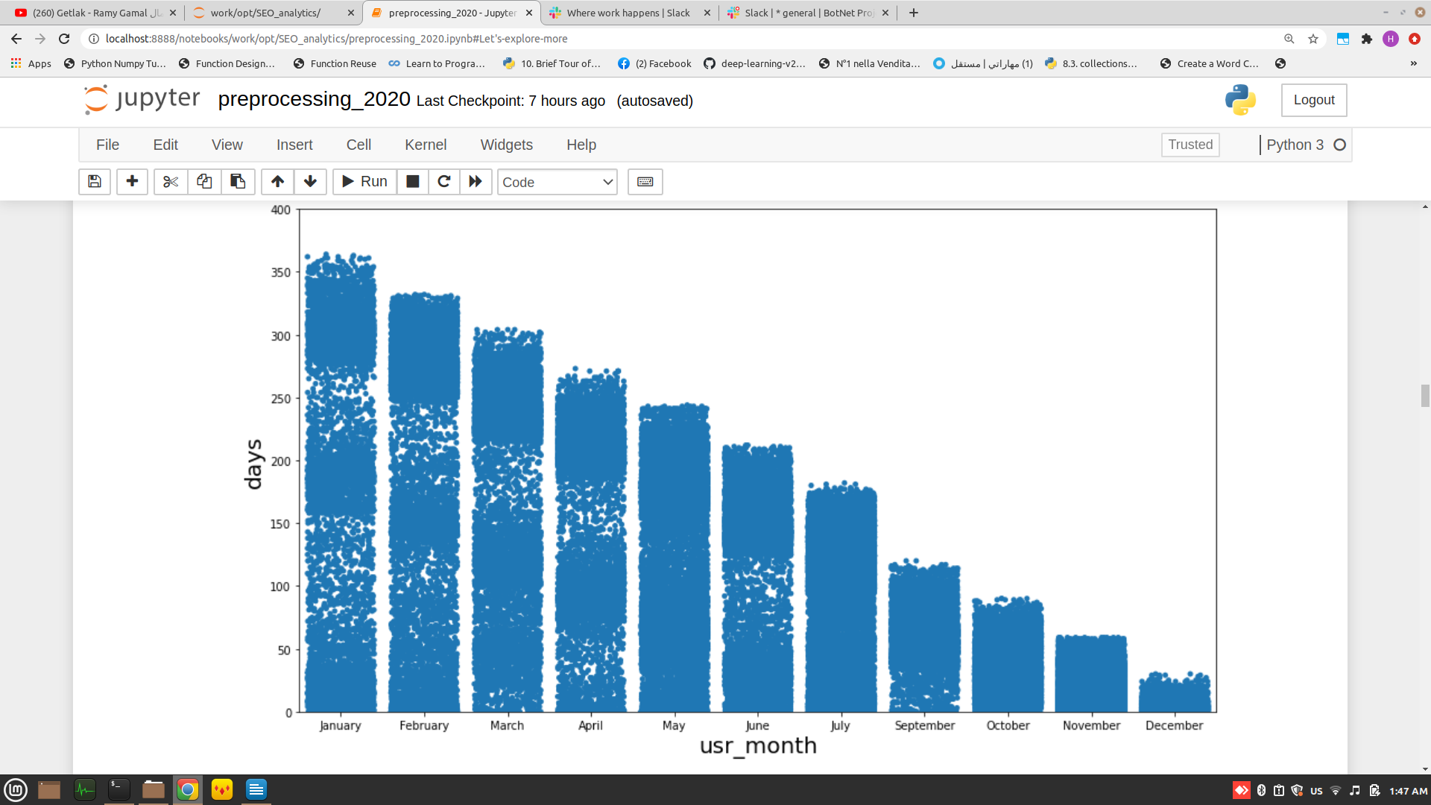

11. That made me look fo further investigation gave a prospective point of view to the whole insights in eac corner of the data, so I explored the tweet_dates that have the highest no. Of tweets, then filtered them to the top trendy_dates that have more than 10000 tweets, found that:

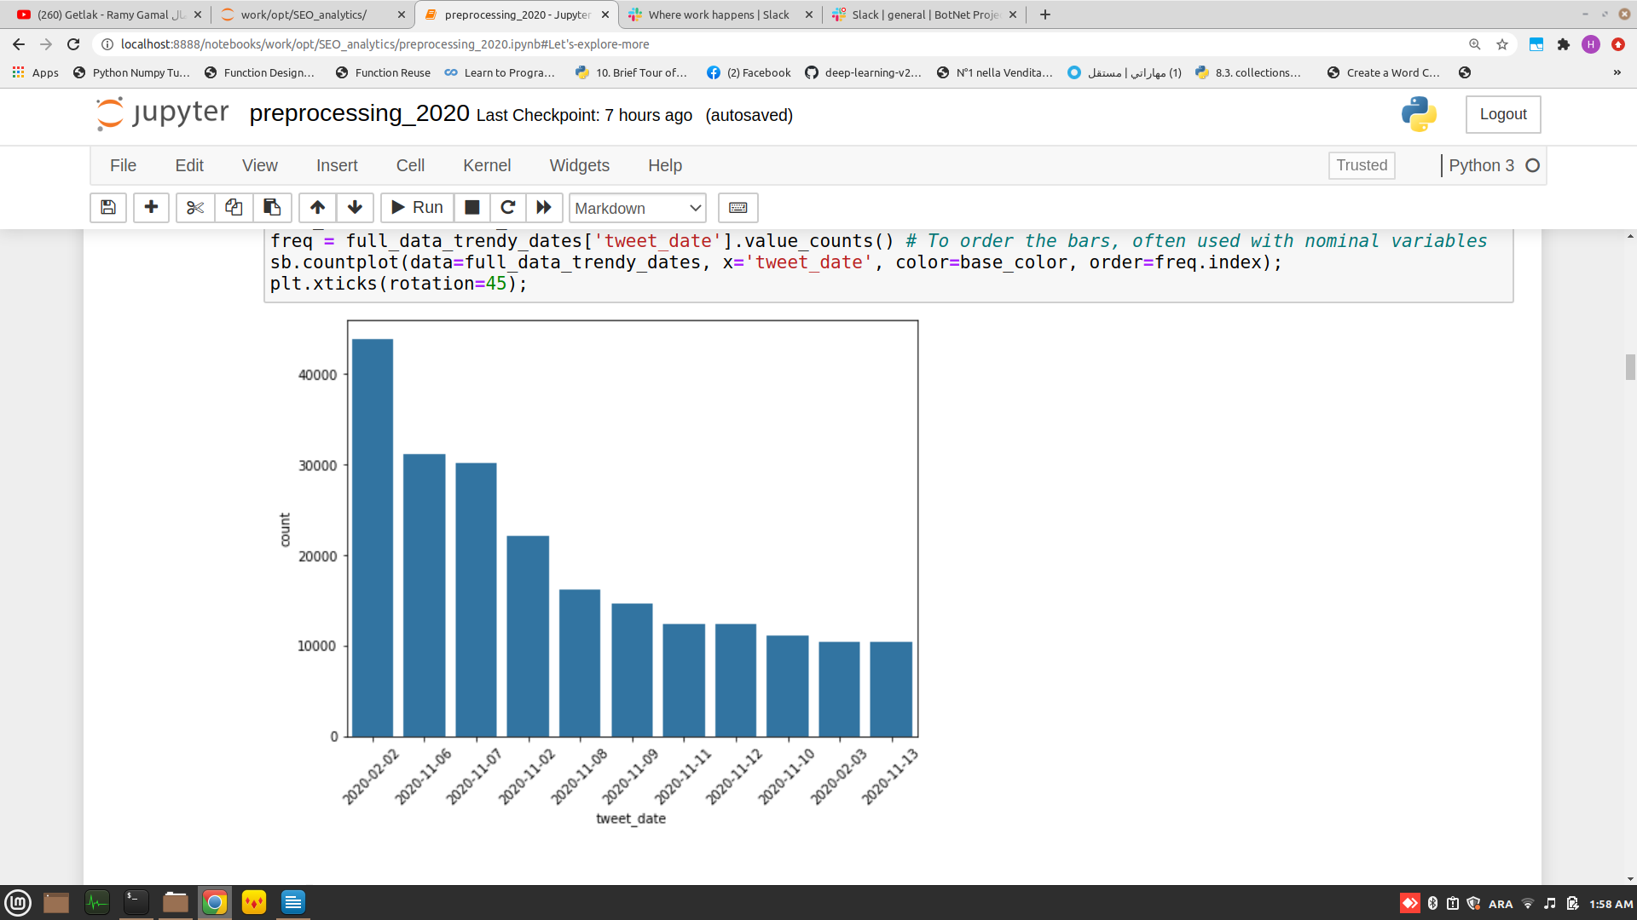

11. That made me explore each month to see the most frequent users tweeted on those dates.

By investigating the July, found that tweets from fresh users are the more bulky in the month specially in trendy dates in july.

### Found that Many tweets are from same user in the same day and also all are fresh users .. by checking the shape pf whole tweets in jul/2020 (59113) .. only from (17596) user_id the no. of tweet from fresh users in same day: (444_ while, the total no. of tweet from 2020 users: (20091) and the no. of frequent fresh users (2020) : (2679)

12. For November, found that many user_ids fresh created and many were with the same user name with hastages and words like (justiceforjhonny)

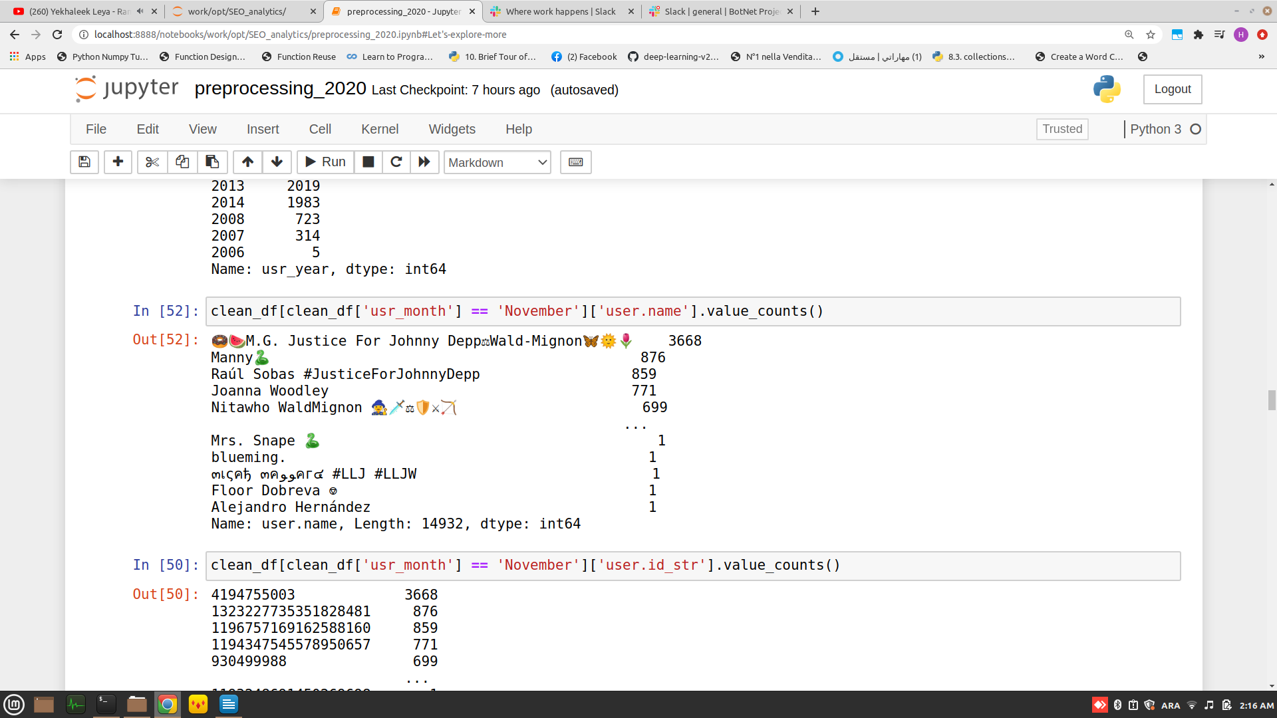Also found that (61180 tweets) .. only (15569 users)[¶](http://localhost:8888/notebooks/work/opt/SEO_analytics/preprocessing_2020.ipynb" \l "The-same-here-(61180-tweets)-..-only-(15569-users)) while the no. of tweet from fresh users in same day: (2846) where the total no. of tweet from 2020 users: (19694) and no. of frequent fresh users (2020) : (2276) also theno. of all frequent users: (15562).

13. The same for August many User.names identical and many are fresh users. with interesting  
names, also (55289 tweets) .. only (16949 users), no. of tweet from fresh users in same day: (153). Total no. of tweet from 2020 users: (14738), no. of frequent fresh users (2020) : (2242), no. of all frequent users: (16949).

14. May also (53739 tweets) .. only (16813 users), no. of tweet from fresh users in same day: (166). Total no. of tweet from 2020 users: (13181), no. of frequent fresh users (2020) : (2729), no. of all frequent users: (16813).

15. For October (45106 tweets) .. only (16159 users), no. of tweet from fresh users in same day: (92). Total no. of tweet from 2020 users: (9855), no. of frequent fresh users (2020) : (2400), no. of all frequent users: (16159).

16. While Febreuary (44727 tweets) .. only (14847 users), no. of tweet from fresh users in same day: (720). Total no. of tweet from 2020 users: (9664), no. of frequent fresh users (2020) : (2308), no. of all frequent users: (14847).

17. April showed (54004 tweets) .. only (16674 users), no. of tweet from fresh users in same day:( 64). Total no. of tweet from 2020 users: (8889), no. of frequent fresh users (2020) : (2575), no. of all frequent users: (16674).

18. Here is March (49879 tweets) .. only (16782 users), no. of tweet from fresh users in same day: (54). Total no. of tweet from 2020 users: (8789), no. of frequent fresh users (2020) : (2279), no. of all frequent users: (16782).

19. January to had (48776 tweets) .. only (17055 users), no. of tweet from fresh users in same day: (62). Total no. of tweet from 2020 users: (8622), no. of frequent fresh users (2020) : (3347), no. of all frequent users: (17055).

20. While June (52317 tweets) .. only (17516 users), the no. of tweet from fresh users in same day: (60). Total no. of tweet from 2020 users: (8412), no. of frequent fresh users (2020) : (2922), no. of all frequent users: (17516).

21. A look to September (43455 tweets) .. only (15633 users). no. of tweet from fresh users in same day: (56). Total no. of tweet from 2020 users: (7809), no. of frequent fresh users (2020) : (2167), no. of all frequent users: (15633).

22. Finally December had (44970 tweets) .. only (14640 users) where no. of tweet from fresh users in same day: (715) and total no. of tweet from 2020 users: (2948) also no. of frequent fresh users (2020) : (2167) so no. of all frequent users: (14640).